

**Assignment Title:**

Coursework

**Coursework Type:**

Individual

# Module Name:

STW4005CEM Database Systems

**Intake:**

September 2024

# Submitted By Submitted To

**Coventry University ID:** 15370374 **Name:** Ayush Kaji Dangol

**College ID:** 240148

**Name:** Biplov Gautam

# Abstract

The paper is designed in the development of an efficient database system for Bhatbhateni Supermarket, one of the leading retail chains in Nepal. The previous system was highly cumbersome with old recording techniques and problems in the maintenance of all inventories, sales, and customer records. Data normalization was extended to 3NF, and the relationship diagram was also drawn. Various SQL queries were run to implement actions like updating prices of products, deleting some sales records, and bulk modification. Besides, Python was used to visualize some CSV data related to supermarket operation for patterns and trends using graphical representation like a line graph, bar chart, histogram, box-and-whisker plot, and pie chart.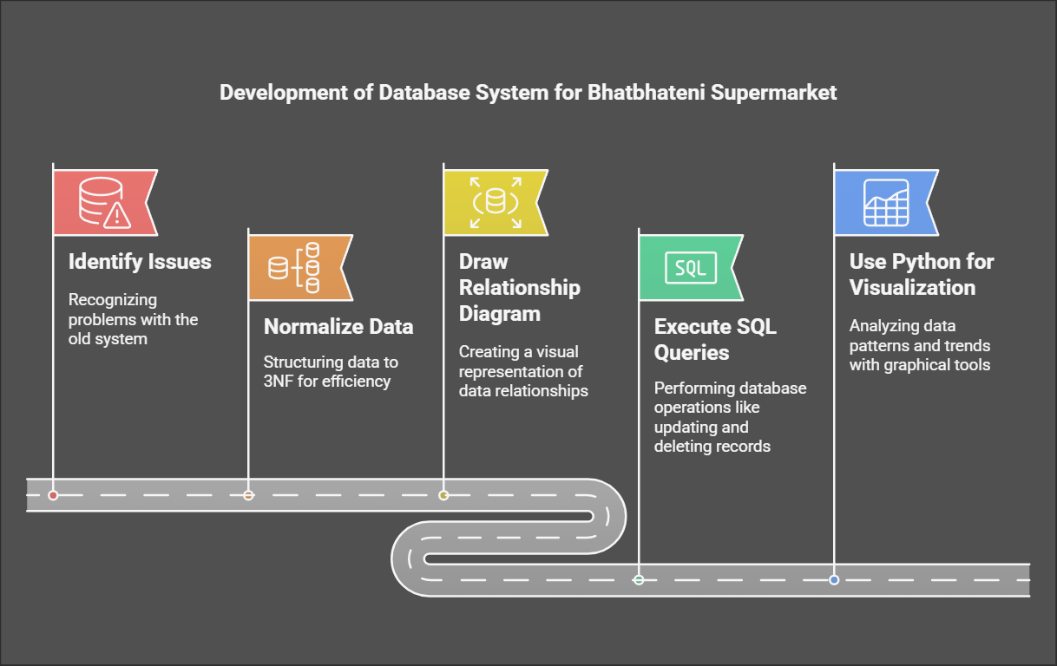

**Table of Content**

[Introduction 4](#_Toc29467)

[Task 1 - Design 5](#_Toc7971)

[Normalization 5](#_Toc24903)

[UNF - Unnormalized Form 6](#_Toc3671)

[1NF - First Normal Form 7](#_Toc6688)

[2NF - Second Normal Form 8](#_Toc13702)

[3NF - Third Normal Form 10](#_Toc1)

[Entity-Relationship Diagram 12](#_Toc32699)

[Task 2 - Data Entry and Data menipulation 14](#_Toc886)

[Structured Query Language - SQL 14](#_Toc20031)

[SQL Task - a 15](#_Toc4074)

[SQL Task - b 22](#_Toc14043)

[SQL Task - c 23](#_Toc3866)

[SQL Task - d 24](#_Toc5232)

[SQL Task - e 26](#_Toc21144)

[SQL Task - f 27](#_Toc22627)

[SQL Task - g 28](#_Toc23755)

[SQL Task - h 29](#_Toc23210)

[SQL Task - i 30](#_Toc6777)

[Task 3 - Data Visualization 31](#_Toc24249)

[Data Visualization 31](#_Toc14112)

[Justification of Columns and Insights from Visualizations 39](#_Toc28140)

[Conclusion 40](#_Toc15157)

[References 41](#_Toc10559)

[Appendix 42](#_Toc7327)

# Introduction

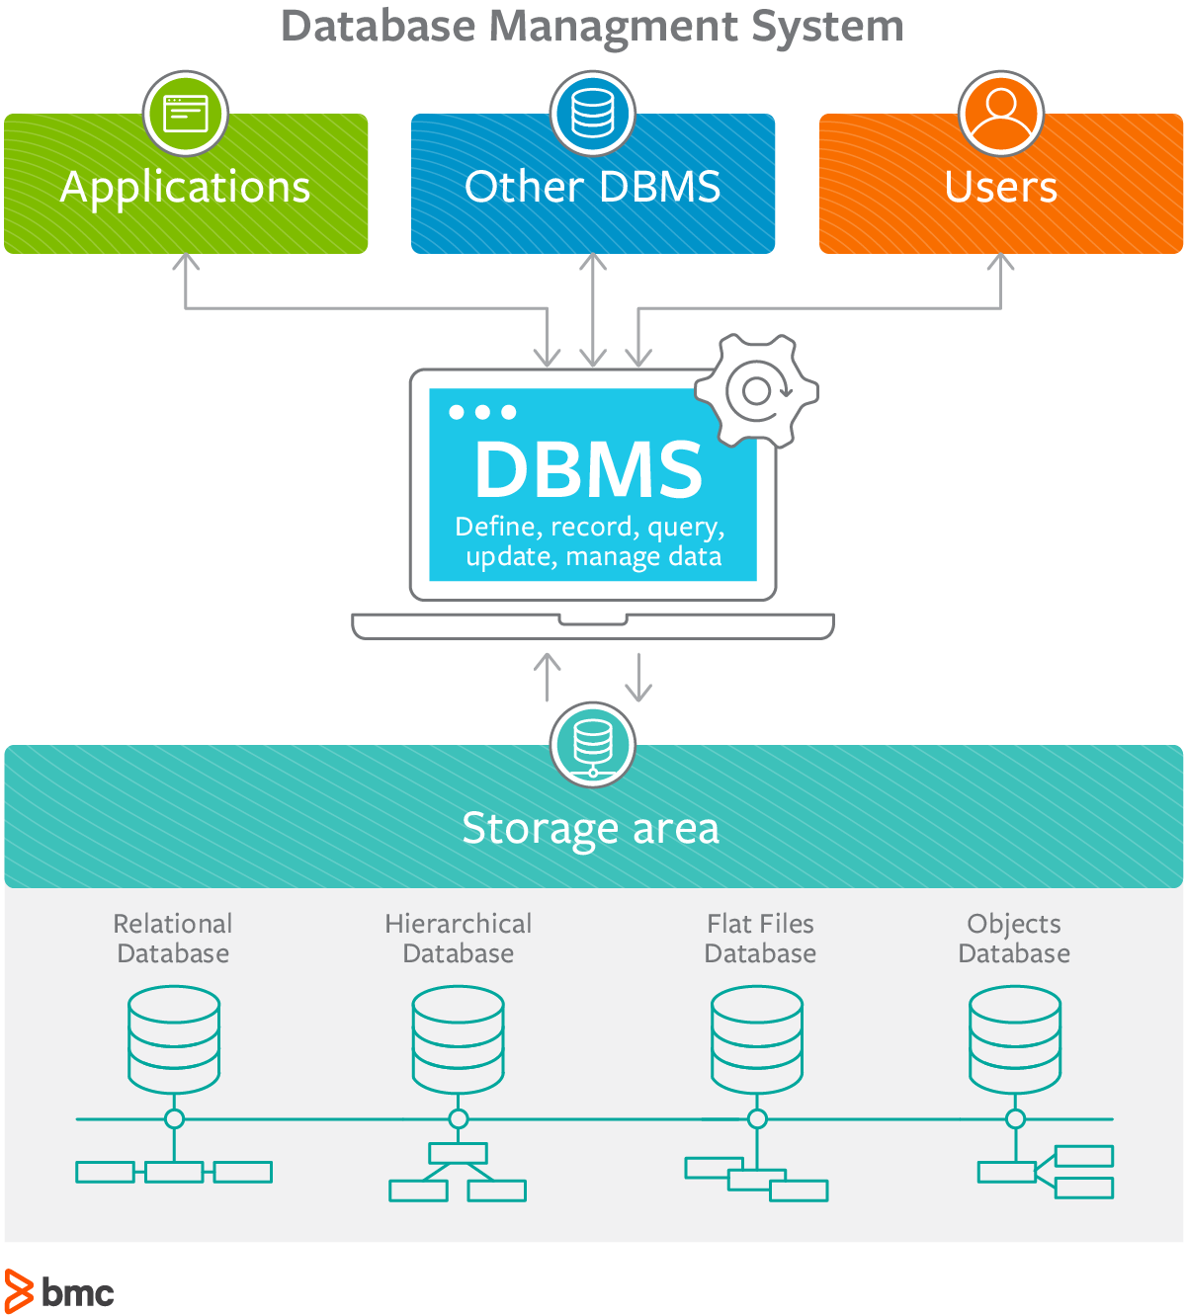Database systems offer a productive end-user interface for software developers, database administrators/designers, IT administrators, and application programs to interact with and manage databases efficiently. Database systems allow users to query, update, sort, and control data storage procedures efficiently. The following is the development of a contemporary database solution for Bhatbhateni Supermarket, a leading retail chain in Nepal. The grocery store was also having problems due to outmoded systems and inefficient means of storing sales, inventory, and customer data. To correct issues, the database was normalized to 3NF and an ER diagram constructed to represent relationships in the information. SQL queries were used to perform basic operations such as updating the prices of products, deleting specific records of sales, and conducting multiple changes. Besides, CSV data for supermarket operations was also graphed using Python with the help of different graphs like line graphs, bar graphs, histograms, box-whisker plots, and pie charts to effectively find patterns and trends.

# Task 1 - Design

## Normalization

Normalization is an important process in database design that helps improve the database’s efficiency, consistency, and accuracy. It makes it easier to manage and maintain the data and ensures that the database is adaptable to changing business needs.

* Database normalization is the process of organizing the attributes of the database to reduce or eliminate data redundancy (having the same data but at different places).
* Data redundancy unnecessarily increases the size of the database as the same data is repeated in many places. Inconsistency problems also arise during insert, delete, and update operations.
* In the relational model, there exist standard methods to quantify how efficient a databases is. These methods are called normal forms and there are algorithms to covert a given database into normal forms.
* Normalization generally involves splitting a table into multiple ones which must be linked each time a query is made requiring data from the split tables..

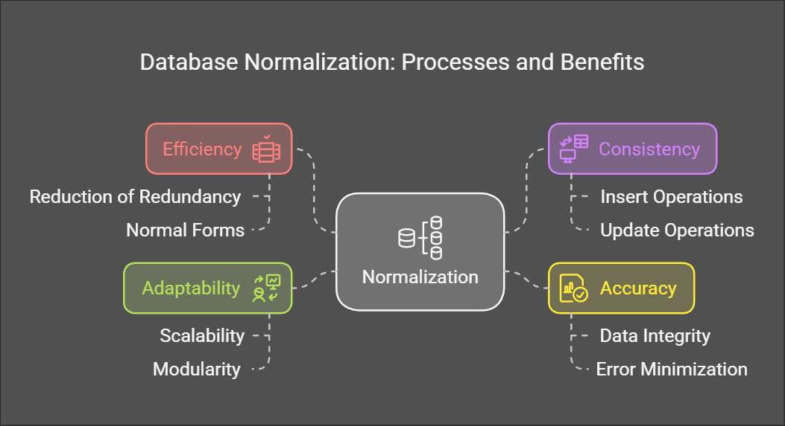

### UNF - Unnormalized Form

An unnormalized table is a raw, unstructured way of storing data in a database. It has redundancies, repeating groups, and data not broken into atomic ( indivisible) values. Such tables tend to introduce inefficiencies, e.g., data anomalies on inserting, deleting, or updating. Unnormalized tables are where the normalization process begins, where data is reorganized into smaller, well-structured tables to remove redundancy and enhance consistency.

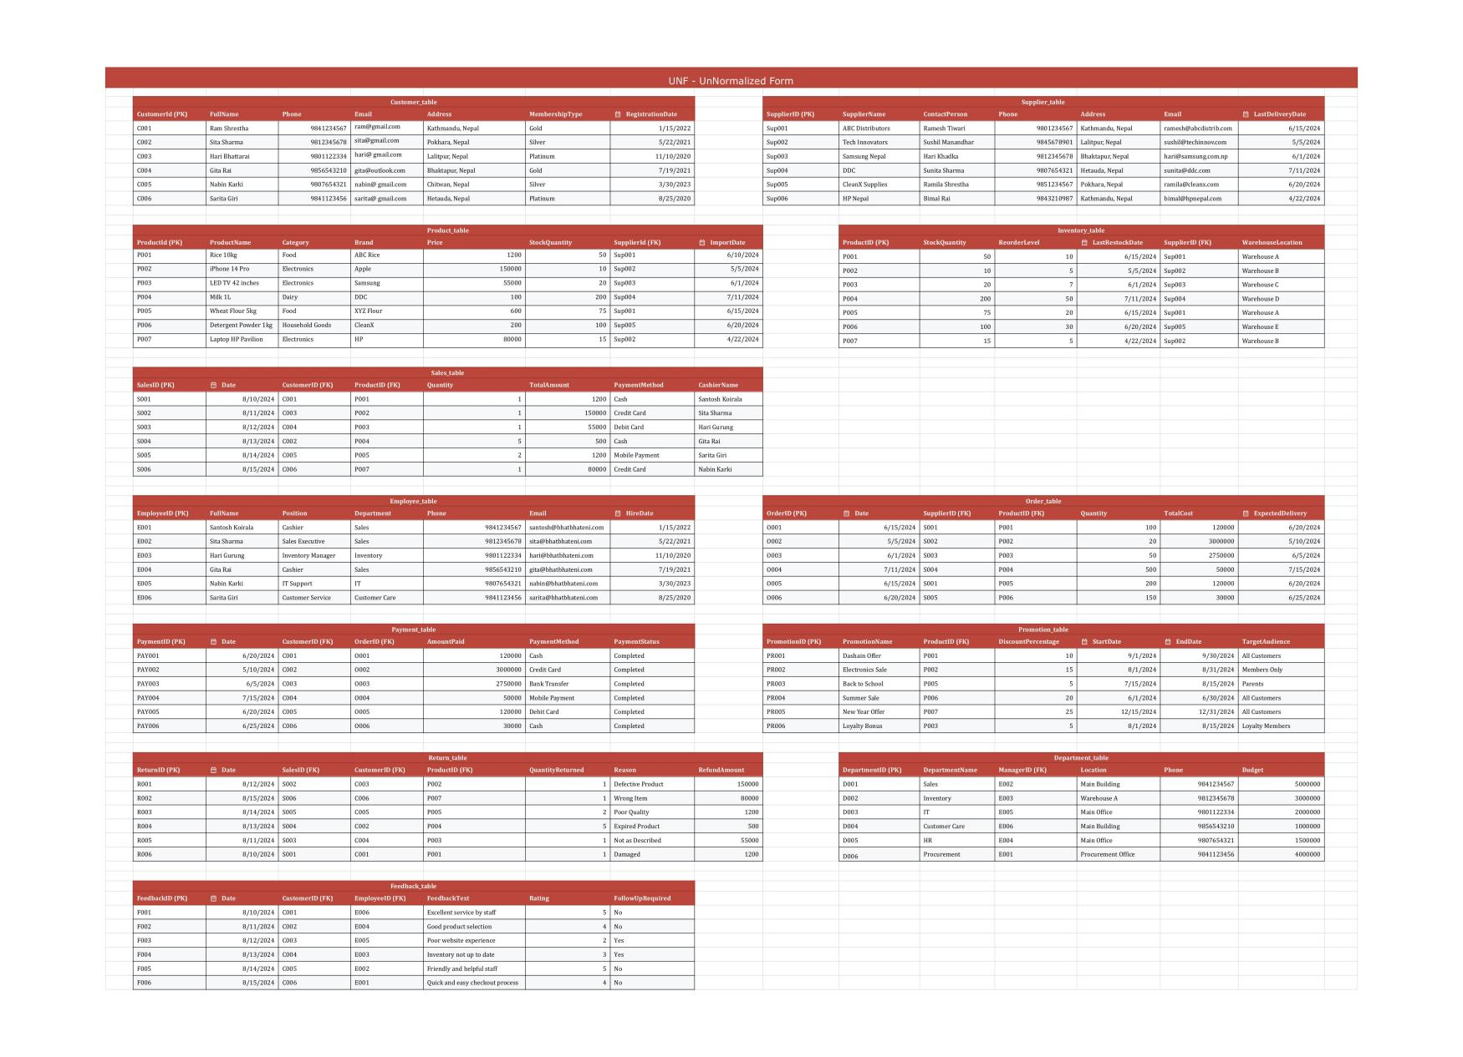*UNF - Unnormalized Form of Bhatbhateni Department Store*

### 1NF - First Normal Form

First Normal Form, or 1NF, is the first step in the development of a well-structured and organized database. A table is considered to be in 1NF when each column contains only atomic values-that is, the data is not broken down into more than one sub-component-and there are no repeating groups or duplicate sets of columns within a single record. This simplifies how data will be represented, reduces data redundancy, and enhances efficiency in management. 1NF lays the very foundation for a sound and robust database.

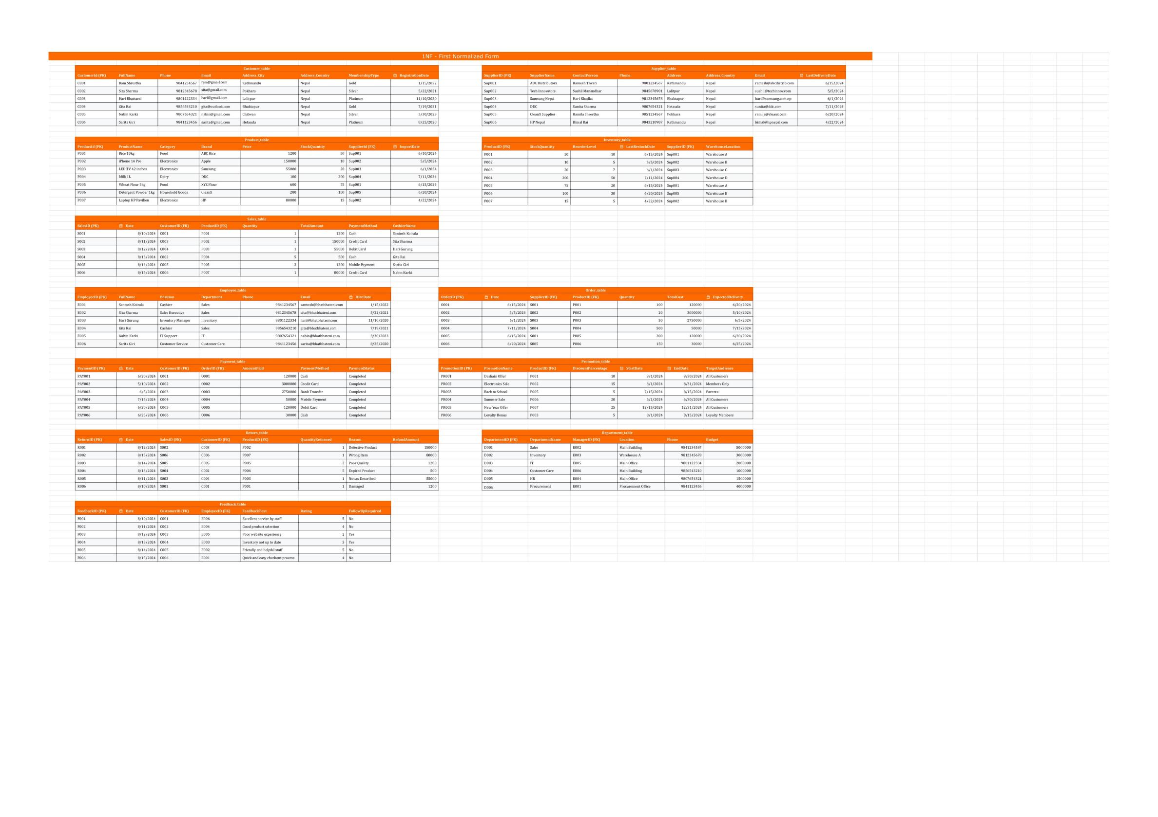

*First Normal Form-1NF for Bhatbhateni Departmental Store*

### 2NF - Second Normal Form

Second Normal Form (2NF) works on the normalization of a relational database by reduction in redundancy. To satisfy 2NF, first, a table must satisfy the terms of 1NF: columns in the table must hold an atomic value and must have non-key attributes entirely dependent upon the primary key, not any part of it. It ensures no partial dependency, thus reducing inefficiency and anomalies during data manipulation, and hence, on updating or deletion of a record, data integrity is maintained.

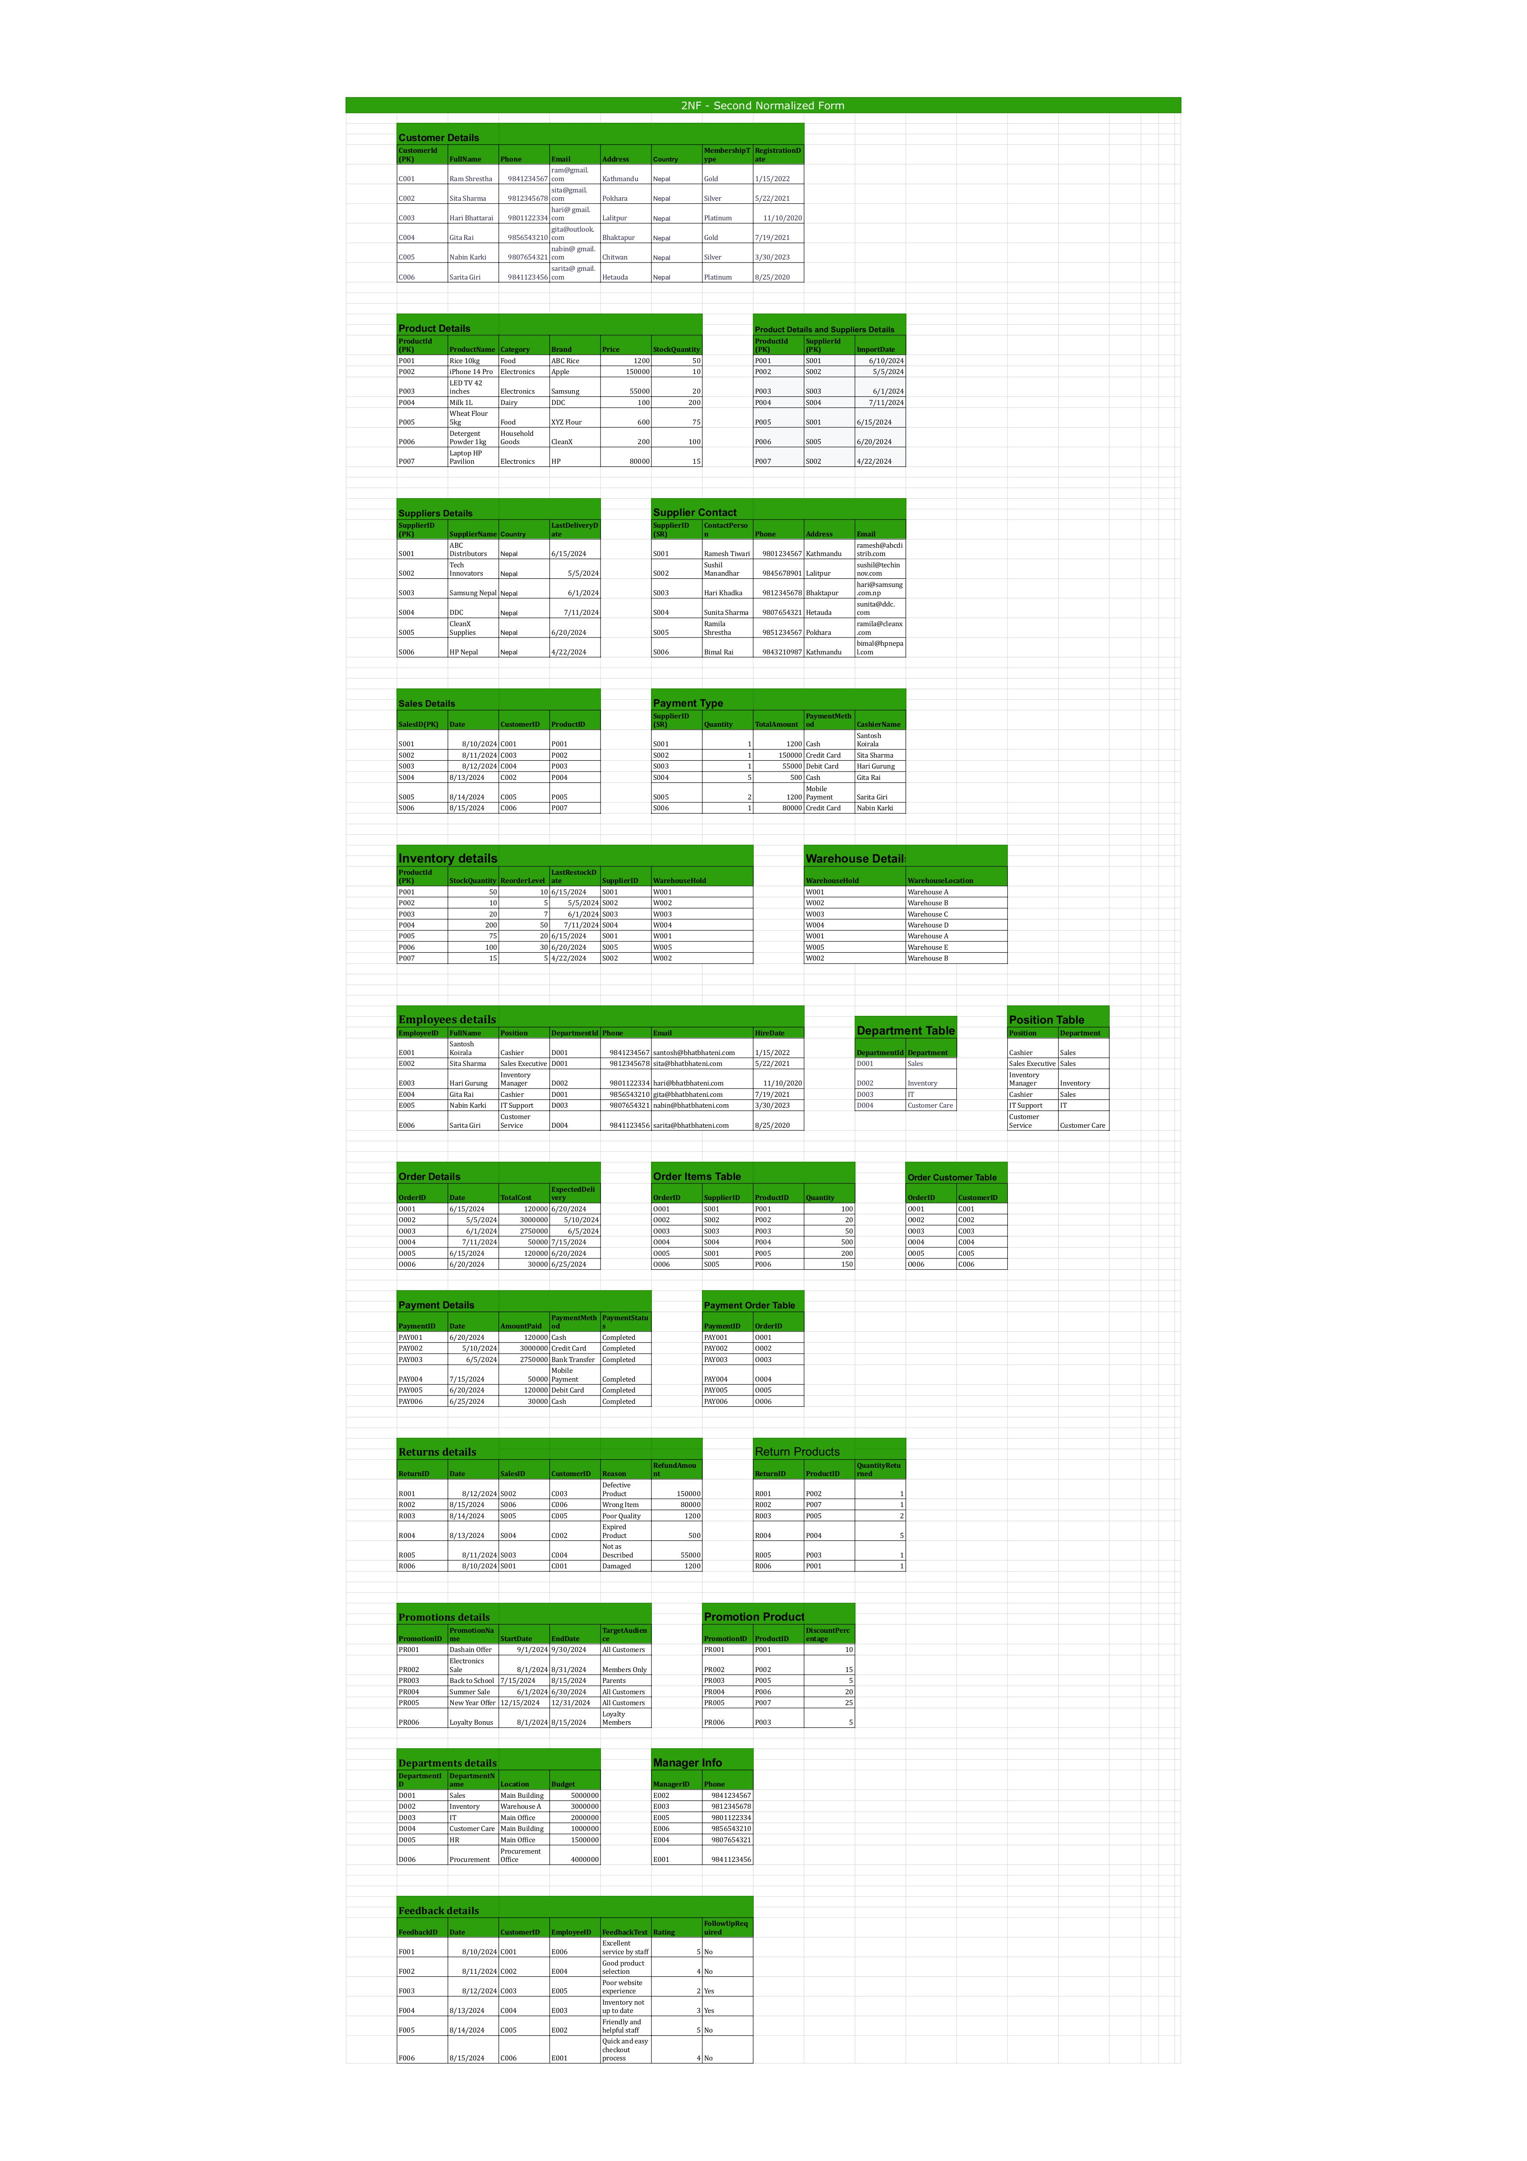



*Second Normal Form-2NF for Bhatbhateni Departmental Store*

### 3NF - Third Normal Form

Third Normal Form - 3NF in database design refers to the cancellation of a transitive dependency beyond that which may exist in 1NF and 2NF. Whereas in 2NF, all non-key attributes must be totally dependent on the whole primary key, 3NF ensures that every non-key attribute depends on no other non-key attribute. To put it differently, each attribute within a table is directly related to the primary key and nothing else. 3NF, by removing these indirect dependencies, makes the database structure less complex, reducing redundancy and thereby lessening the occurrence of anomalies during updates, deletions, or insertions. This leads to a neat, maintainable, and efficient design of the database.

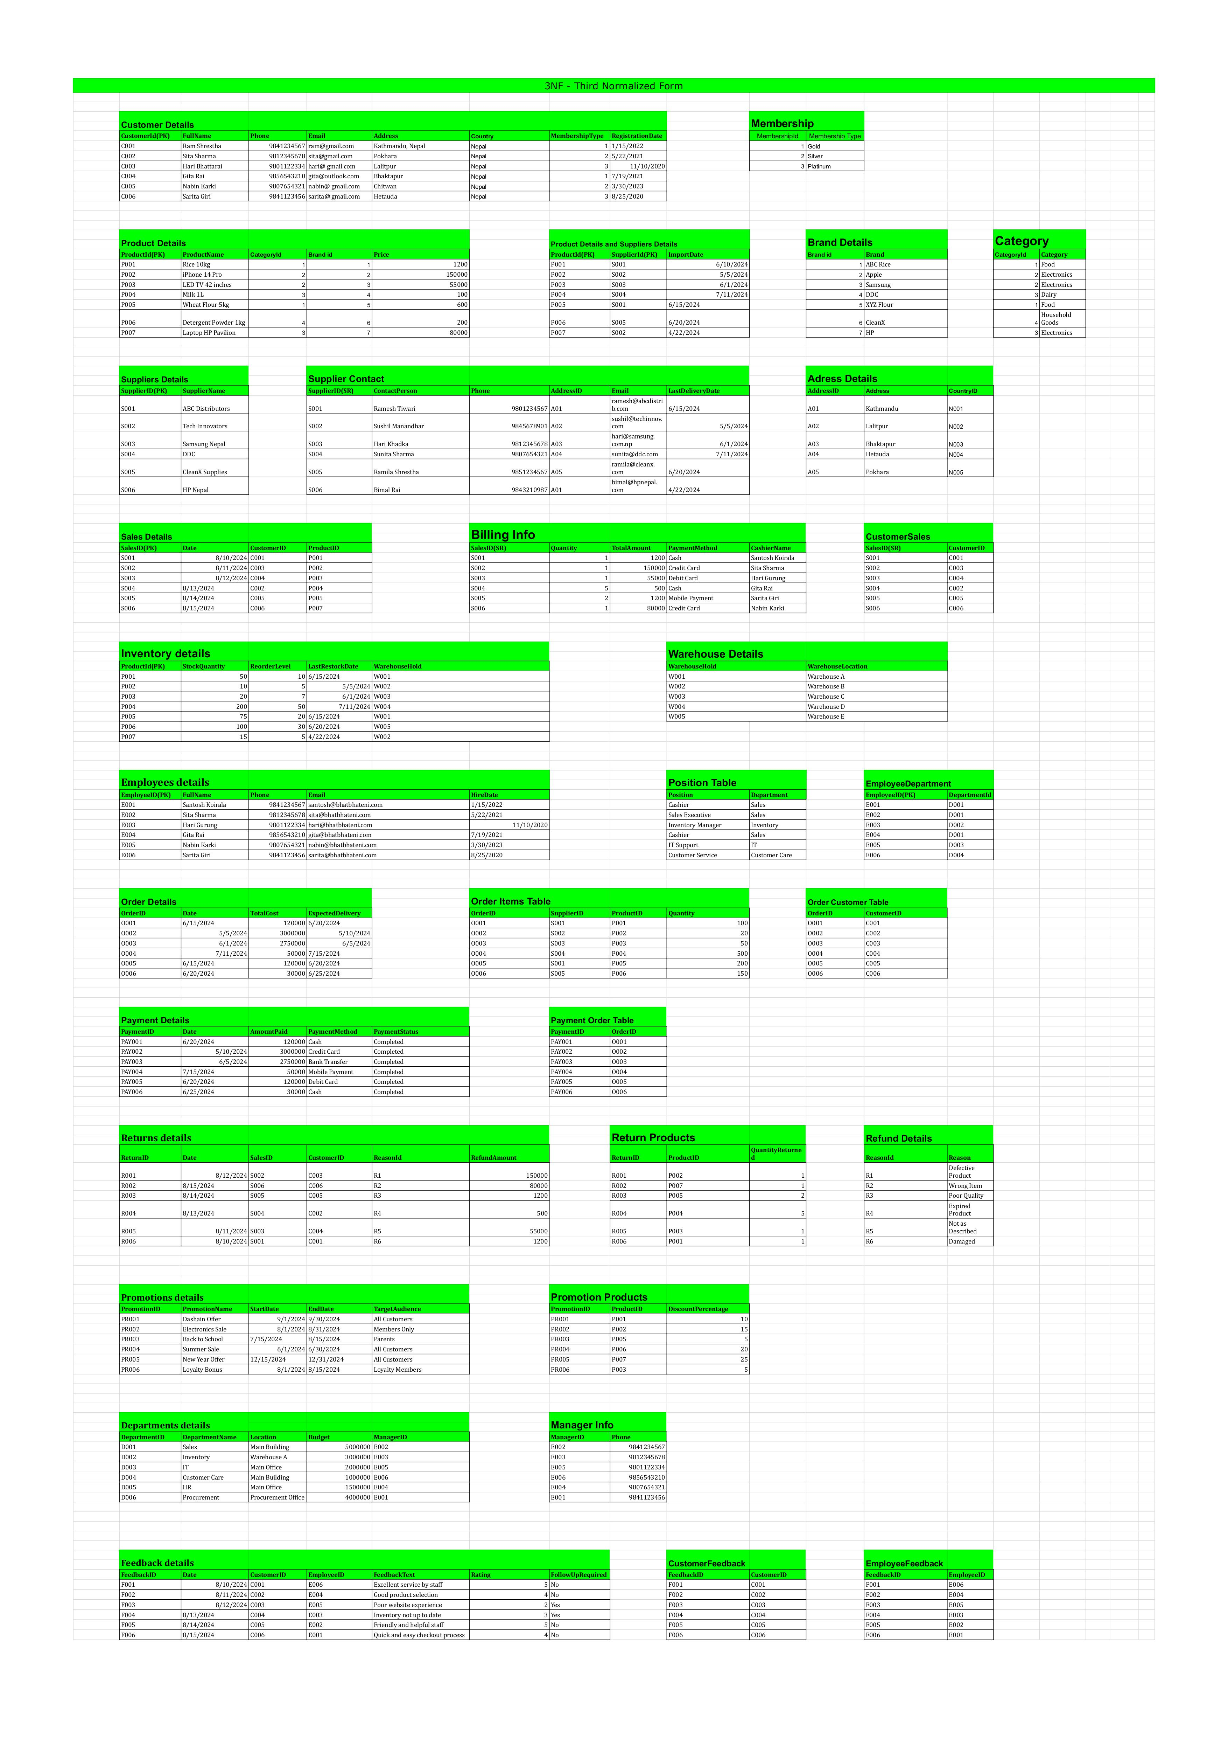*Third Normal Form for Bhatbhateni Departmental Store – Part 1*



*Third Normal Form for Bhatbhateni Departmental Store – Part 2*

## Entity-Relationship Diagram

An ER diagram is a structure for visually depicting the outline of a database. Within it, entities or objects are depicted as rectangles, relationships among them are shown as diamonds, and attributes or the properties of the entities as ovals. The diagram will help in understanding how different entities interact with each other; for example, a customer placing an order. It also shows the cardinality of the relationships: one-to-one, one-to-many, or many-to-many. This helps the database design be neat and effective. ER diagrams are crucial in the development of clear and well-structured databases.

After normalizing to 3NF for all tables of BhatBhateni departmental store, I drew an ER diagram because it is more structured to work with models and construct the database efficiently.

### C:\Users\ASUS\Downloads\Untitled (1).pngUntitled (1)Drafted ER diagram - without relation

### Final ER - With relation

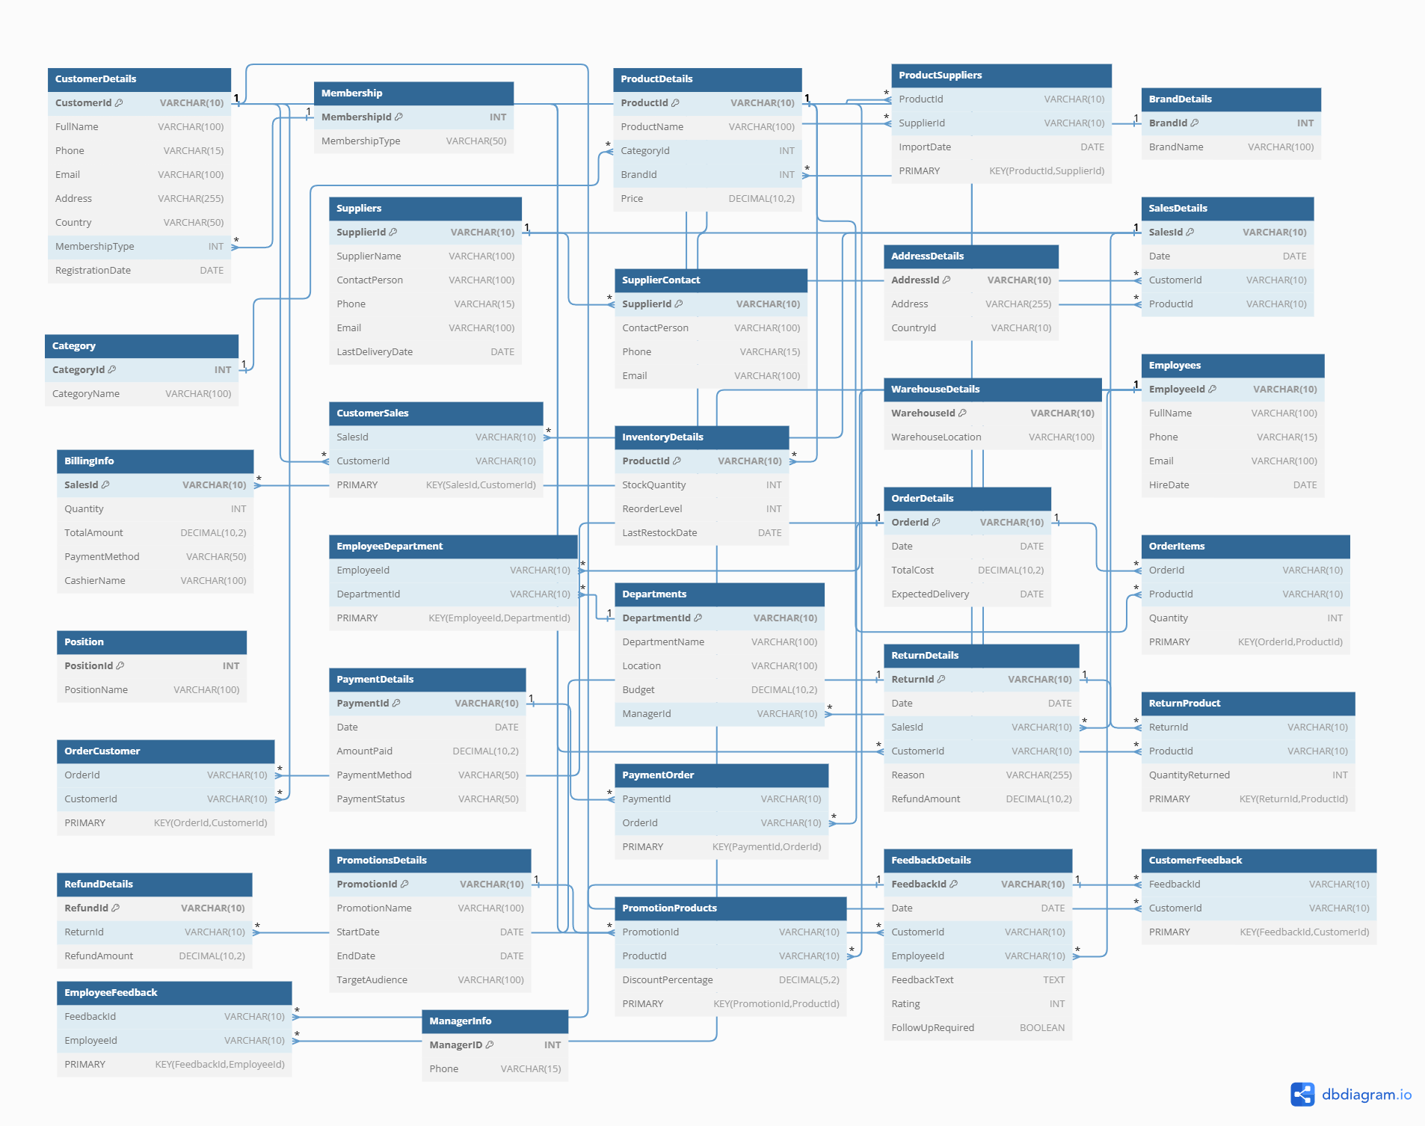

# Task 2 - Data Entry and Data menipulation

## Structured Query Language - SQL

SQL stands for Structured Query Language, and this is a program language used to operate, feed, and modify data in relational databases. It, in turn, allows users to implement various kinds of operations: data selection, insertion, update, and deletion. SQL works in a way that writes commands, using queries, to interact with a database to facilitate the process of organizing, analyzing, and updating of huge volumes of data efficiently. It is usually used for focusing on customer management, transaction processing, and reporting.

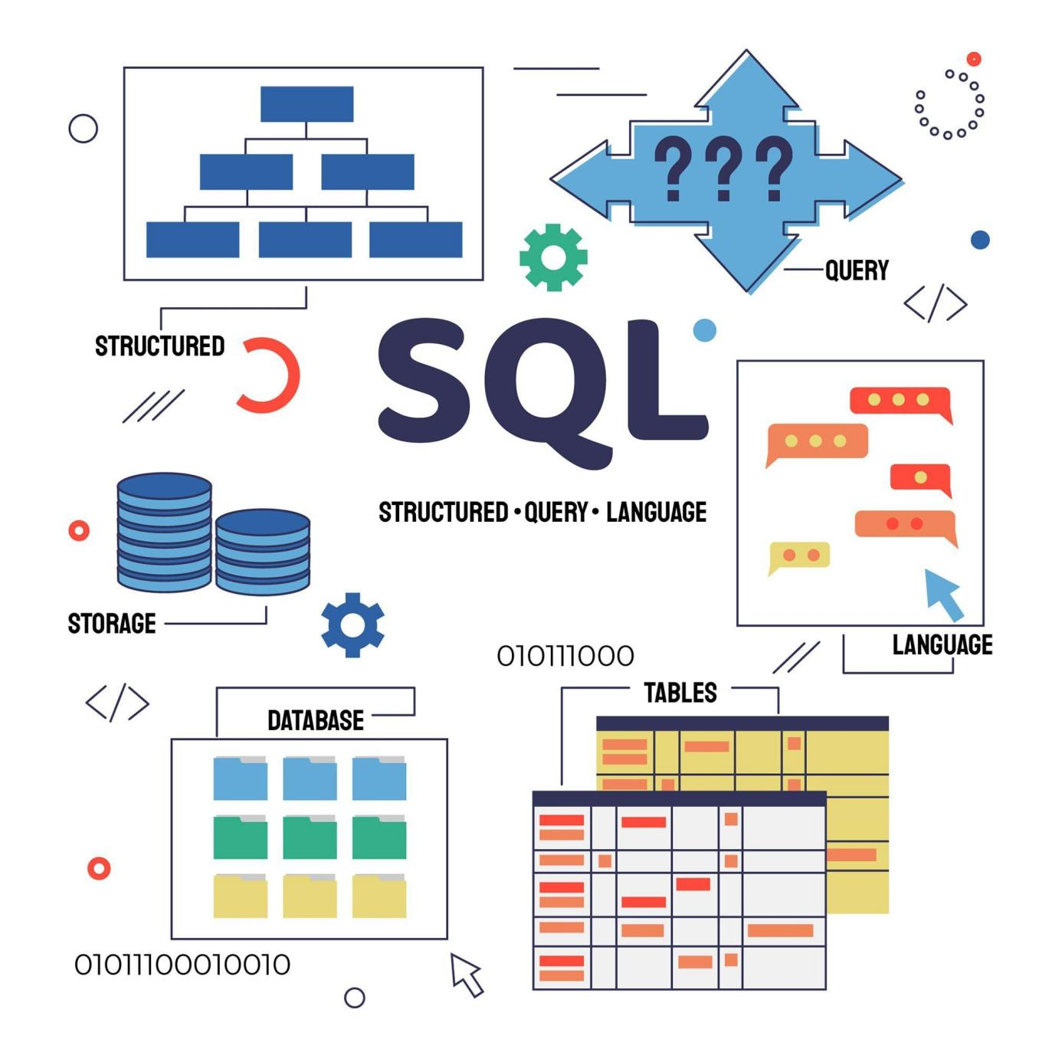After normalizing the given BhatBhateni departmental store tables up to 3NF, I have written the required and appropriate SQL queries to create SQL tables from the normalized structure. Later, these were executed to complete all given course work tasks accordingly.

### SQL Task - a

Creating database in mysql and creating tables

Create database database\_assignment;

Use database\_assignment;

-- Customer Details Table

CREATE TABLE CustomerDetails (

    CustomerId VARCHAR(10) PRIMARY KEY,

    FullName VARCHAR(100),

    Phone VARCHAR(15),

    Email VARCHAR(100),

    Address VARCHAR(255),

    Country VARCHAR(50),

    MembershipType INT,

    RegistrationDate DATE

);

-- Membership Table

CREATE TABLE Membership (

    MembershipId INT PRIMARY KEY,

    MembershipType VARCHAR(50)

);

-- Product Details Table

CREATE TABLE ProductDetails (

    ProductId VARCHAR(10) PRIMARY KEY,

    ProductName VARCHAR(100),

    CategoryId INT,

    BrandId INT,

    Price DECIMAL(10, 2)

);

-- Product Details and Suppliers Table

CREATE TABLE ProductSuppliers (

    ProductId VARCHAR(10),

    SupplierId VARCHAR(10),

    ImportDate DATE,

    PRIMARY KEY (ProductId, SupplierId),

    FOREIGN KEY (ProductId) REFERENCES ProductDetails(ProductId),

    FOREIGN KEY (SupplierId) REFERENCES Suppliers(SupplierId)

);

-- Brand Details Table

CREATE TABLE BrandDetails (

    BrandId INT PRIMARY KEY,

    BrandName VARCHAR(100)

);

-- Category Table

CREATE TABLE Category (

    CategoryId INT PRIMARY KEY,

    CategoryName VARCHAR(100)

);

-- Suppliers Details Table

CREATE TABLE Suppliers (

    SupplierId VARCHAR(10) PRIMARY KEY,

    SupplierName VARCHAR(100),

    ContactPerson VARCHAR(100),

    Phone VARCHAR(15),

    Email VARCHAR(100),

    LastDeliveryDate DATE

);

-- Supplier Contact Table

CREATE TABLE SupplierContact (

    SupplierId VARCHAR(10),

    ContactPerson VARCHAR(100),

    Phone VARCHAR(15),

    Email VARCHAR(100),

    PRIMARY KEY (SupplierId),

    FOREIGN KEY (SupplierId) REFERENCES Suppliers(SupplierId)

);

-- Address Details Table

CREATE TABLE AddressDetails (

    AddressId VARCHAR(10) PRIMARY KEY,

    Address VARCHAR(255),

    CountryId VARCHAR(10)

);

-- Sales Details Table

CREATE TABLE SalesDetails (

    SalesId VARCHAR(10) PRIMARY KEY,

    Date DATE,

    CustomerId VARCHAR(10),

    ProductId VARCHAR(10),

    FOREIGN KEY (CustomerId) REFERENCES CustomerDetails(CustomerId),

    FOREIGN KEY (ProductId) REFERENCES ProductDetails(ProductId)

);

-- Billing Info Table

CREATE TABLE BillingInfo (

    SalesId VARCHAR(10),

    Quantity INT,

    TotalAmount DECIMAL(10, 2),

    PaymentMethod VARCHAR(50),

    CashierName VARCHAR(100),

    PRIMARY KEY (SalesId),

    FOREIGN KEY (SalesId) REFERENCES SalesDetails(SalesId)

);

-- Customer Sales Table

CREATE TABLE CustomerSales (

    SalesId VARCHAR(10),

    CustomerId VARCHAR(10),

    FOREIGN KEY (SalesId) REFERENCES SalesDetails(SalesId),

    FOREIGN KEY (CustomerId) REFERENCES CustomerDetails(CustomerId)

);

-- Inventory Details Table

CREATE TABLE InventoryDetails (

    ProductId VARCHAR(10),

    StockQuantity INT,

    ReorderLevel INT,

    LastRestockDate DATE,

    PRIMARY KEY (ProductId),

    FOREIGN KEY (ProductId) REFERENCES ProductDetails(ProductId)

);

-- Warehouse Details Table

CREATE TABLE WarehouseDetails (

    WarehouseId VARCHAR(10) PRIMARY KEY,

    WarehouseLocation VARCHAR(100)

);

-- Employees Details Table

CREATE TABLE Employees (

    EmployeeId VARCHAR(10) PRIMARY KEY,

    FullName VARCHAR(100),

    Phone VARCHAR(15),

    Email VARCHAR(100),

    HireDate DATE

);

-- Position Table

CREATE TABLE Position (

    PositionId INT PRIMARY KEY,

    PositionName VARCHAR(100)

);

-- Employee Department Table

CREATE TABLE EmployeeDepartment (

    EmployeeId VARCHAR(10),

    DepartmentId VARCHAR(10),

    PRIMARY KEY (EmployeeId, DepartmentId),

    FOREIGN KEY (EmployeeId) REFERENCES Employees(EmployeeId),

FOREIGN KEY (DepartmentId) REFERENCES Departments(DepartmentId)

);

-- Departments Details Table

CREATE TABLE Departments (

    DepartmentId VARCHAR(10) PRIMARY KEY,

    DepartmentName VARCHAR(100),

    Location VARCHAR(100),

    Budget DECIMAL(10, 2),

    ManagerId VARCHAR(10),

    FOREIGN KEY (ManagerId) REFERENCES Employees(EmployeeId)

);

-- Order Details Table

CREATE TABLE OrderDetails (

    OrderId VARCHAR(10) PRIMARY KEY,

    Date DATE,

    TotalCost DECIMAL(10, 2),

    ExpectedDelivery DATE

);

-- Order Items Table

CREATE TABLE OrderItems (

    OrderId VARCHAR(10),

    ProductId VARCHAR(10),

    Quantity INT,

    PRIMARY KEY (OrderId, ProductId),

    FOREIGN KEY (OrderId) REFERENCES OrderDetails(OrderId),

    FOREIGN KEY (ProductId) REFERENCES ProductDetails(ProductId)

);

-- Order Customer Table

CREATE TABLE OrderCustomer (

    OrderId VARCHAR(10),

    CustomerId VARCHAR(10),

    PRIMARY KEY (OrderId, CustomerId),

    FOREIGN KEY (OrderId) REFERENCES OrderDetails(OrderId),

    FOREIGN KEY (CustomerId) REFERENCES CustomerDetails(CustomerId)

);

-- Payment Details Table

CREATE TABLE PaymentDetails (

    PaymentId VARCHAR(10) PRIMARY KEY,

    Date DATE,

    AmountPaid DECIMAL(10, 2),

    PaymentMethod VARCHAR(50),

    PaymentStatus VARCHAR(50)

);

-- Payment Order Table

CREATE TABLE PaymentOrder (

    PaymentId VARCHAR(10),

    OrderId VARCHAR(10),

    PRIMARY KEY (PaymentId, OrderId),

    FOREIGN KEY (PaymentId) REFERENCES PaymentDetails(PaymentId),

    FOREIGN KEY (OrderId) REFERENCES OrderDetails(OrderId)

);

-- Return Details Table

CREATE TABLE ReturnDetails (

    ReturnId VARCHAR(10) PRIMARY KEY,

    Date DATE,

    SalesId VARCHAR(10),

    CustomerId VARCHAR(10),

    Reason VARCHAR(255),

    RefundAmount DECIMAL(10, 2),

    FOREIGN KEY (SalesId) REFERENCES SalesDetails(SalesId),

    FOREIGN KEY (CustomerId) REFERENCES CustomerDetails(CustomerId)

);

-- Return Product Table

CREATE TABLE ReturnProduct (

    ReturnId VARCHAR(10),

    ProductId VARCHAR(10),

    QuantityReturned INT,

    PRIMARY KEY (ReturnId, ProductId),

    FOREIGN KEY (ReturnId) REFERENCES ReturnDetails(ReturnId),

    FOREIGN KEY (ProductId) REFERENCES ProductDetails(ProductId)

);

-- Refund Details Table

CREATE TABLE RefundDetails (

    RefundId VARCHAR(10) PRIMARY KEY,

    ReturnId VARCHAR(10),

    RefundAmount DECIMAL(10, 2),

    FOREIGN KEY (ReturnId) REFERENCES ReturnDetails(ReturnId)

);

-- Promotions Details Table

CREATE TABLE PromotionsDetails (

    PromotionId VARCHAR(10) PRIMARY KEY,

    PromotionName VARCHAR(100),

    StartDate DATE,

    EndDate DATE,

    TargetAudience VARCHAR(100)

);

-- Promotion Products Table

CREATE TABLE PromotionProducts (

    PromotionId VARCHAR(10),

    ProductId VARCHAR(10),

    DiscountPercentage DECIMAL(5, 2),

    PRIMARY KEY (PromotionId, ProductId),

    FOREIGN KEY (PromotionId) REFERENCES PromotionsDetails(PromotionId),

    FOREIGN KEY (ProductId) REFERENCES ProductDetails(ProductId)

);

-- Feedback Details Table

CREATE TABLE FeedbackDetails (

    FeedbackId VARCHAR(10) PRIMARY KEY,

    Date DATE,

    CustomerId VARCHAR(10),

    EmployeeId VARCHAR(10),

    FeedbackText TEXT,

    Rating INT,

    FollowUpRequired BOOLEAN,

    FOREIGN KEY (CustomerId) REFERENCES CustomerDetails(CustomerId),

    FOREIGN KEY (EmployeeId) REFERENCES Employees(EmployeeId)

);

-- Customer Feedback Table

CREATE TABLE CustomerFeedback (

    FeedbackId VARCHAR(10),

    CustomerId VARCHAR(10),

    PRIMARY KEY (FeedbackId, CustomerId),

    FOREIGN KEY (FeedbackId) REFERENCES FeedbackDetails(FeedbackId),

    FOREIGN KEY (CustomerId) REFERENCES CustomerDetails(CustomerId)

);

-- Employee Feedback Table

CREATE TABLE EmployeeFeedback (

    FeedbackId VARCHAR(10),

    EmployeeId VARCHAR(10),

    PRIMARY KEY (FeedbackId, EmployeeId),

    FOREIGN KEY (FeedbackId) REFERENCES FeedbackDetails(FeedbackId),

    FOREIGN KEY (EmployeeId) REFERENCES Employees(EmployeeId)

);

CREATE TABLE ManagerInfo (

    ManagerID INT PRIMARY KEY,

    Phone VARCHAR(15)

);

## Result of created tables in database

*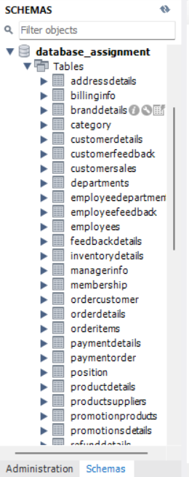*

*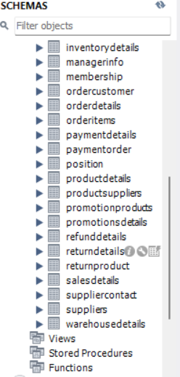*

### SQL Task - b

### Before update

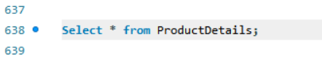

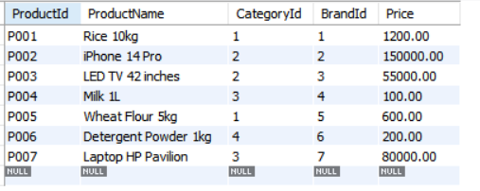

### **C:\Users\ASUS\Pictures\Screenshots\Screenshot 2025-01-26 233810.pngScreenshot 2025-01-26 233810**After update

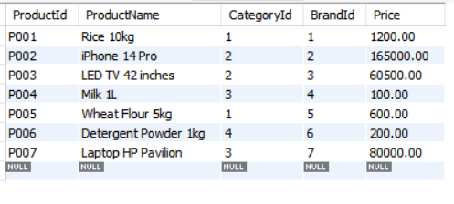

### SQL Task - c

### Before Deletion

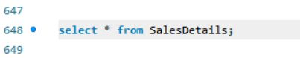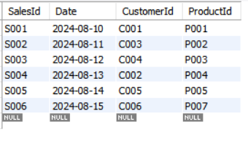

### After Deletion

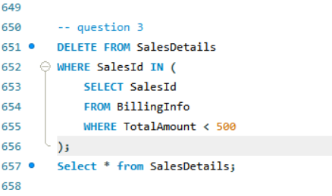

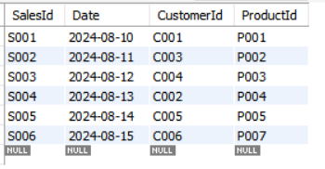

### SQL Task - d

### Before Insertion

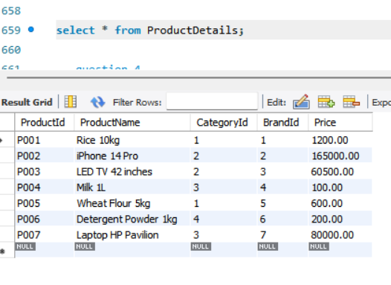

### After Insertion

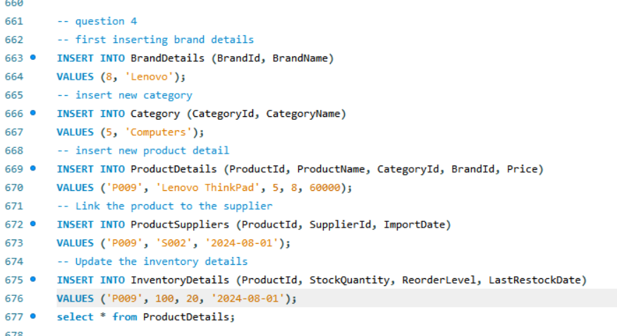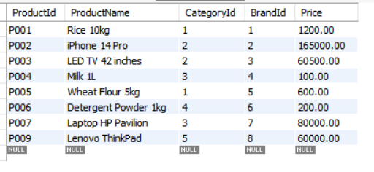

### SQL Task - e

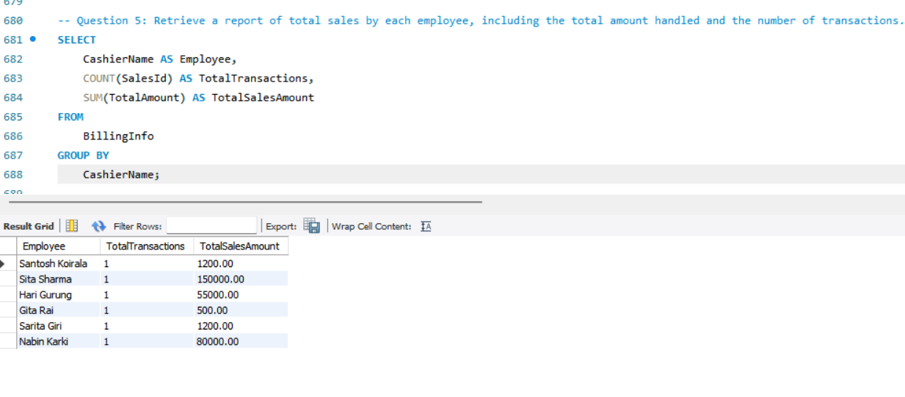

### SQL Task - f

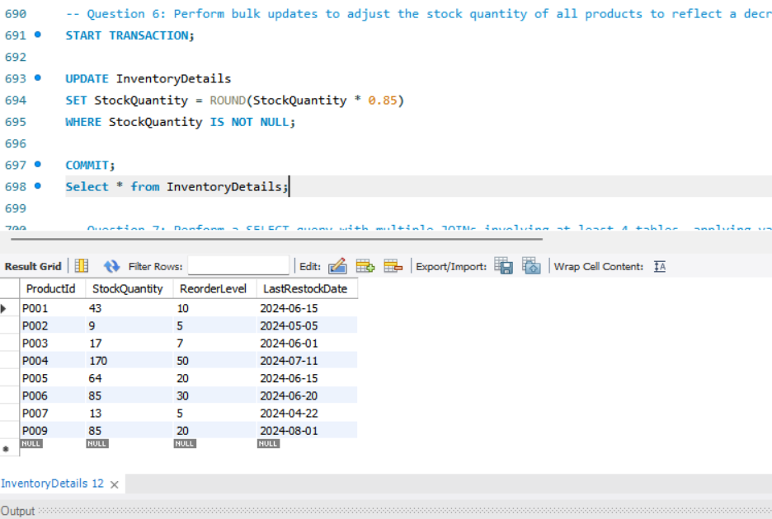

### SQL Task - g

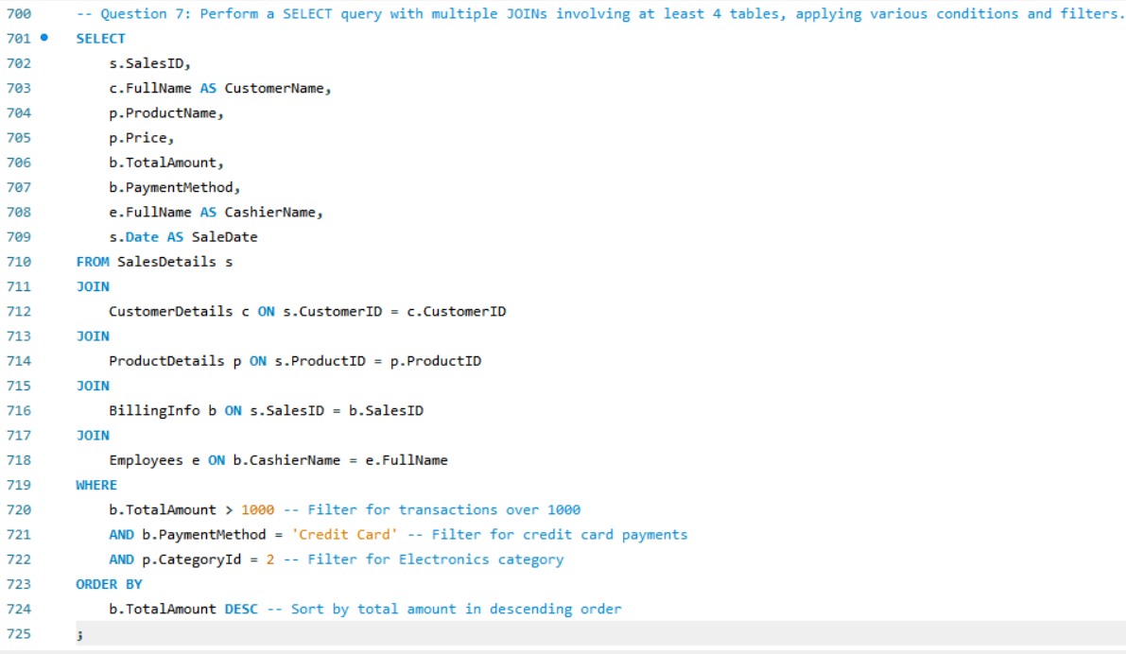

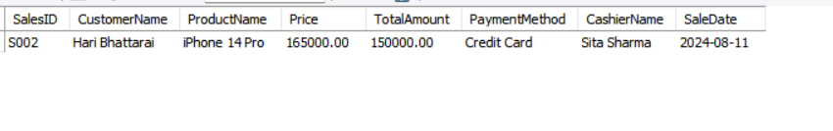

### SQL Task - h

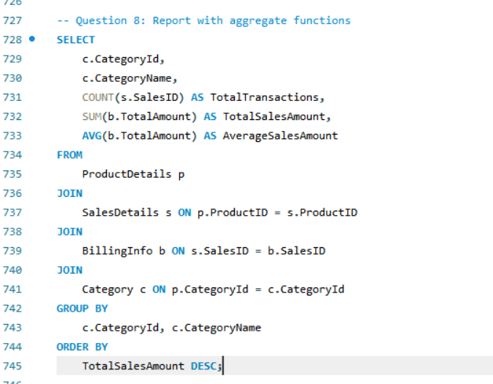

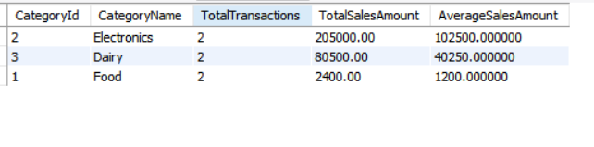

### SQL Task - i

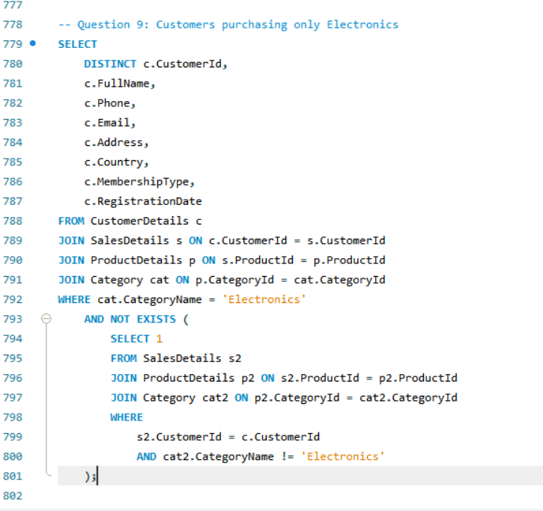

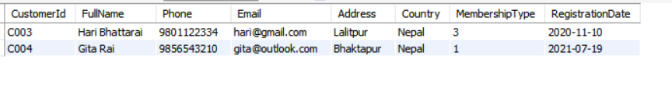

# Task 3 - Data Visualization

## Data Visualization

Data visualization is a method of communicating data in such a way that the individual seeing it is helped in understanding and insight from it. Converting raw data to graphical representation, one can get the pattern, trend, or correlation of the data that otherwise might be very hard or beyond the ability of a normal person. It makes complicated data more understandable and usable.

Other core roles of visualization encompass a wide range of data analysis aspects, including cleaning to find outliers and irregularities. Visualization also helps in the discovery process of data, identification of trends, and communication of results in more comprehensible ways for stakeholders. Whether in exploratory data analysis or in mining, one critical step involves assurance of data quality, where visualization plays a very powerful role.

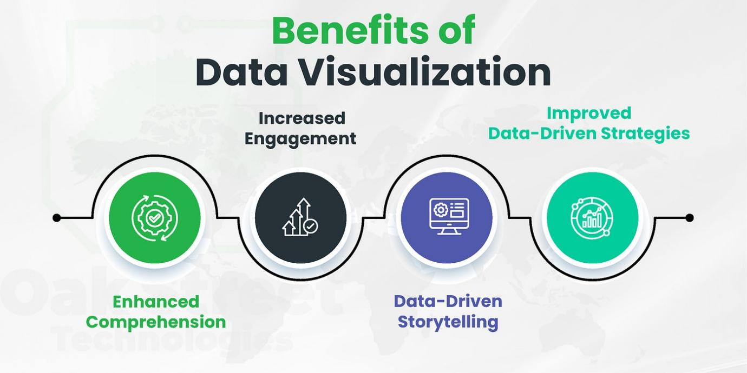

The sample store dataset has been designed to retain deep insight into retail operations by including shipping method, customer segment, and geographical details such as country, city, state, and postal code. It further classifies the products across regions, categories, and subcategories, keeping track of metrics such as sales, quantity, discounts, and profit. This dataset, therefore, forms the basis on which customer preference, product trend, and regional performance analysis can be done in order to facilitate informed business decisions.

### Raw csv file

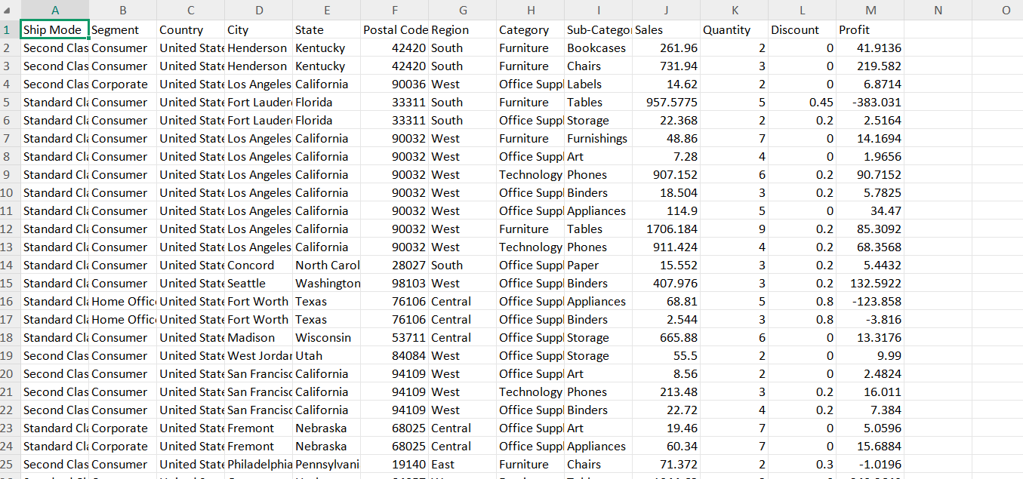

### Visualization in python

*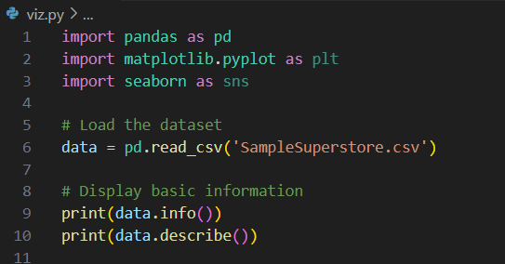*

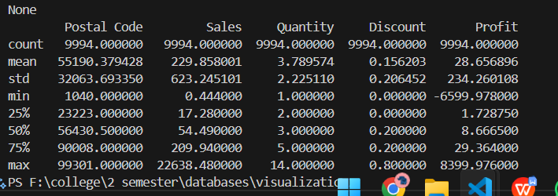

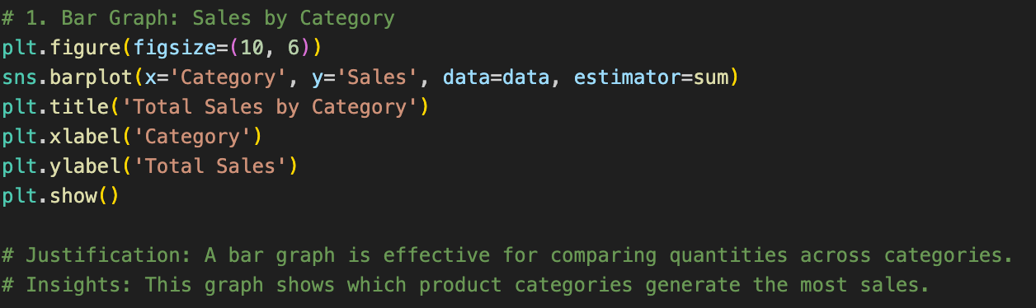

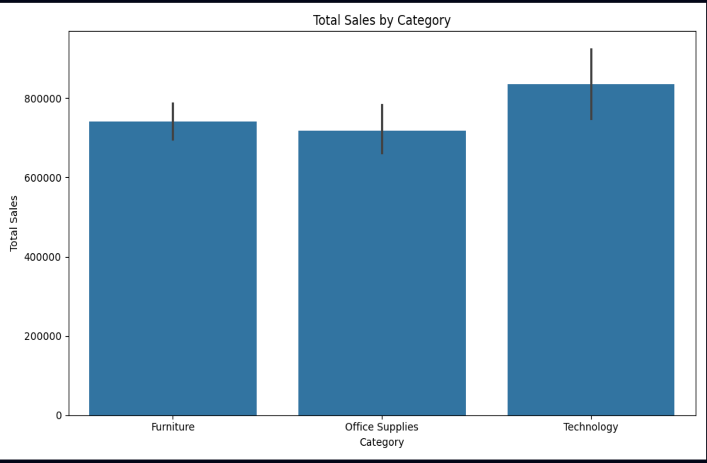

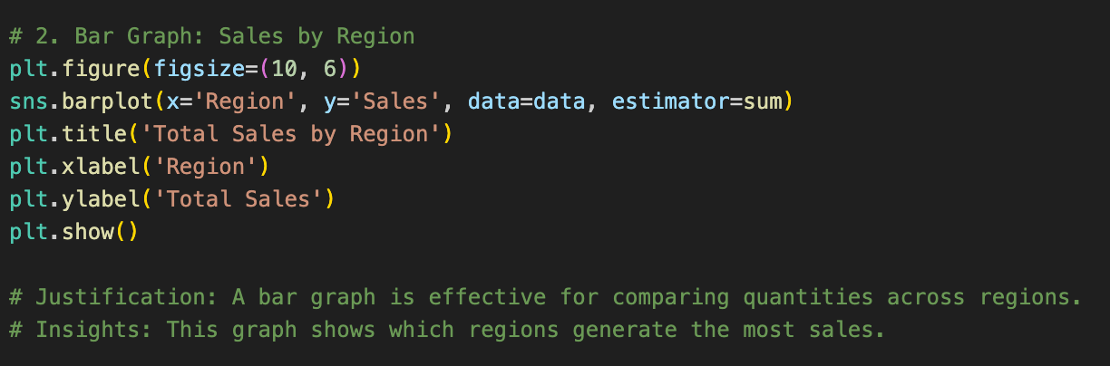

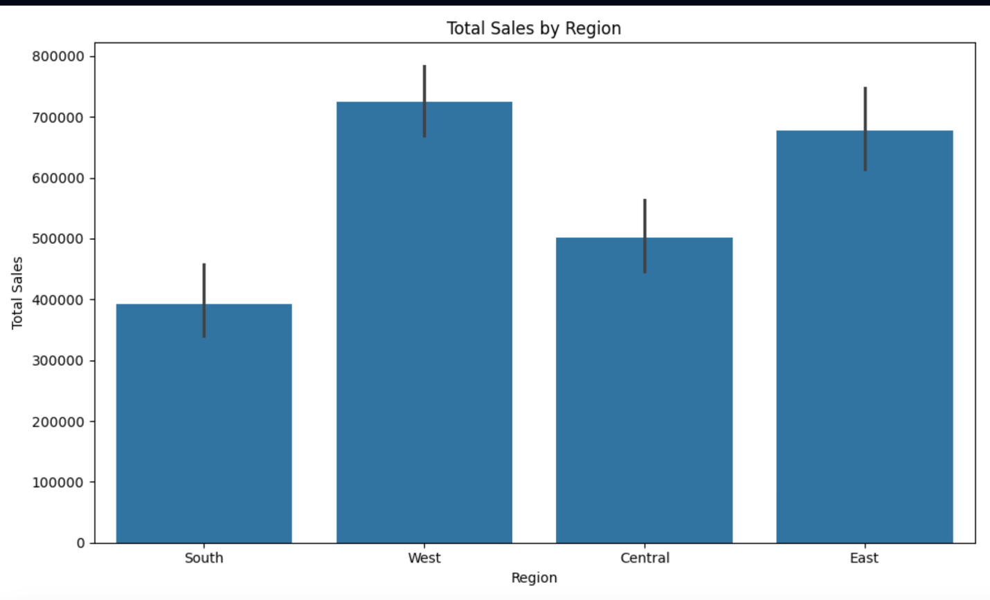

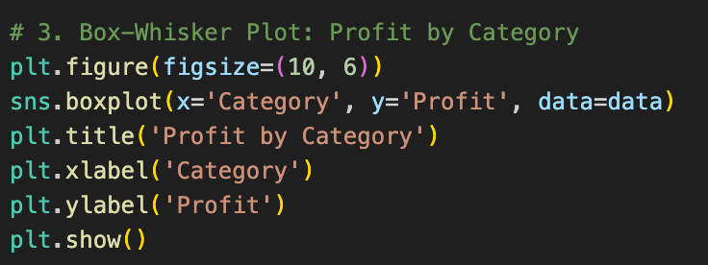

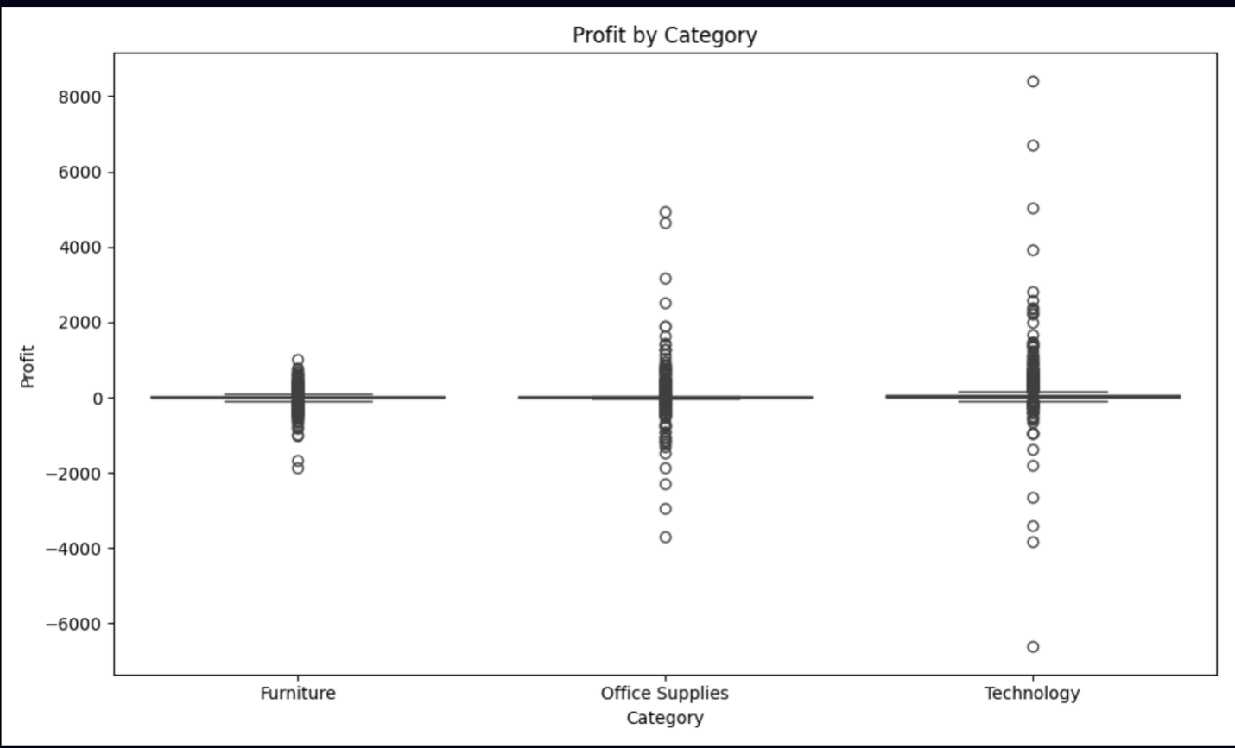

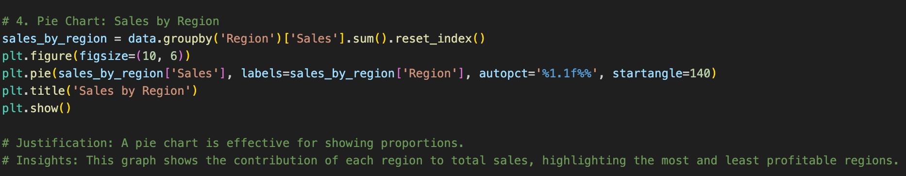

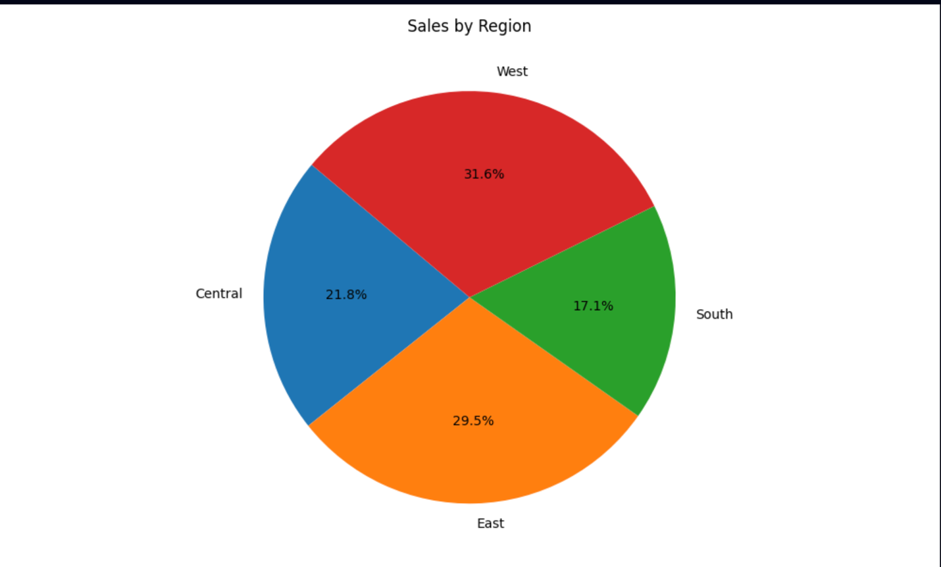

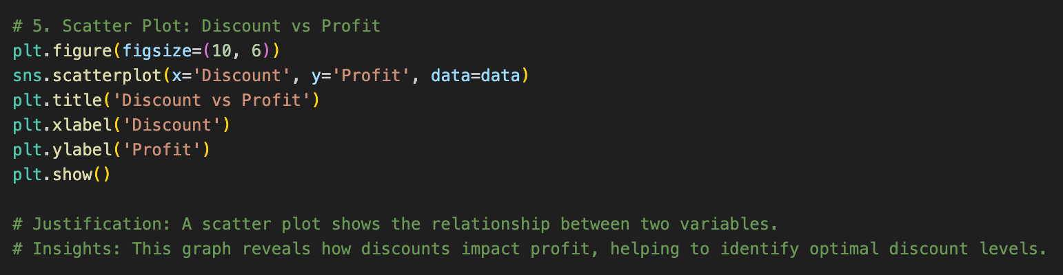

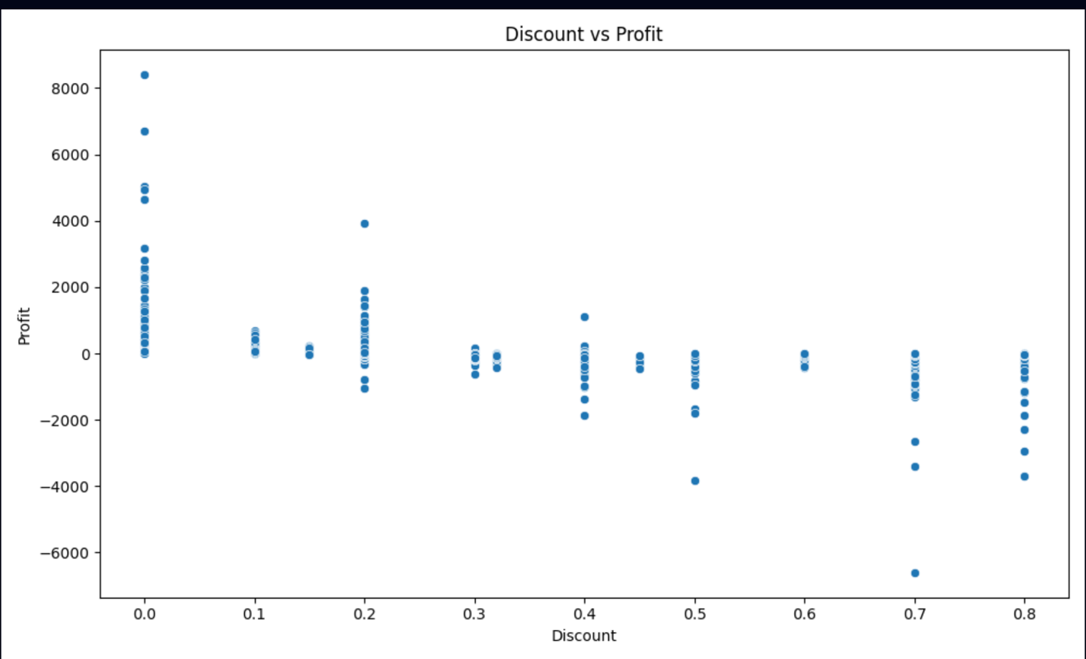

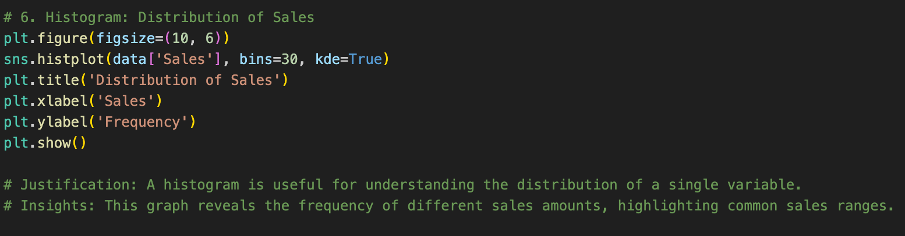

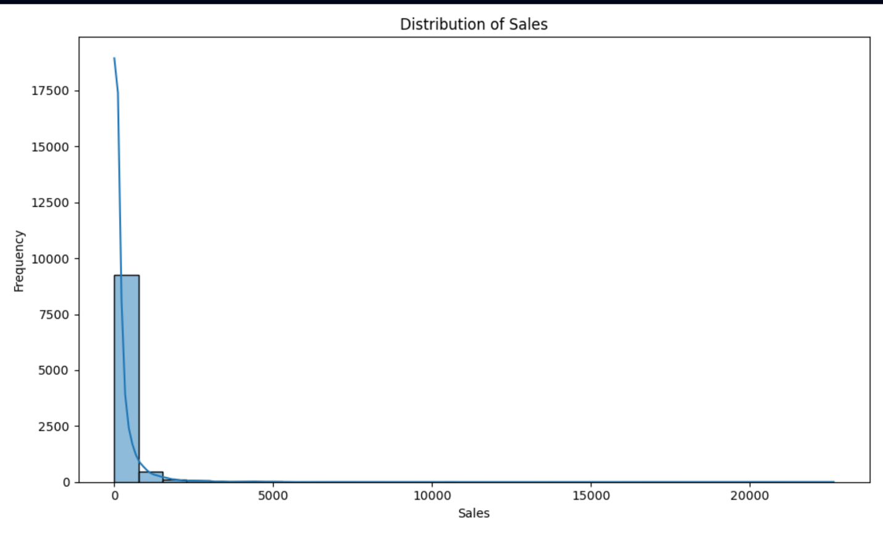

*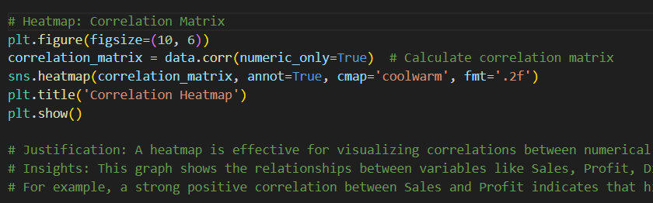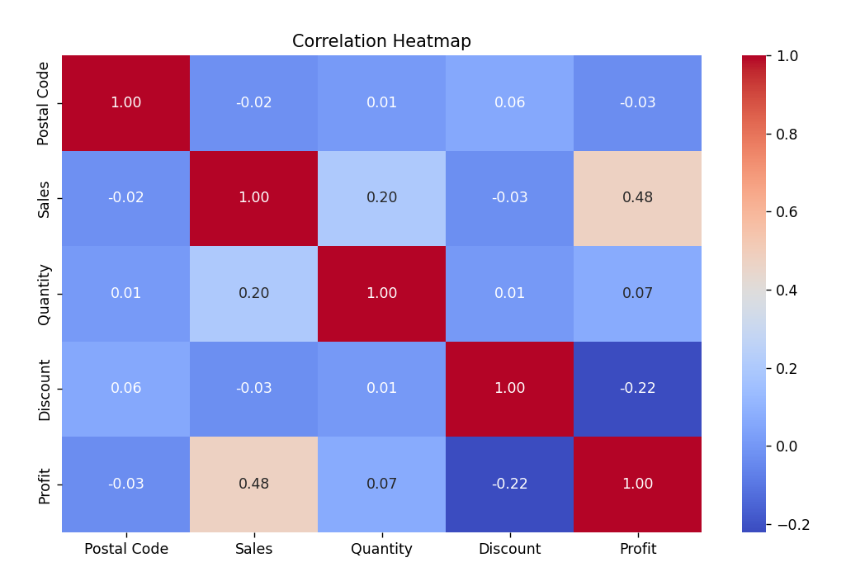*

*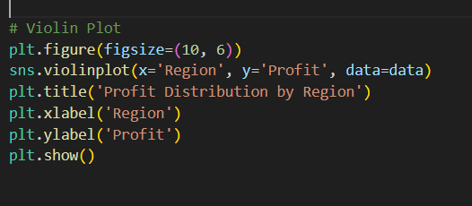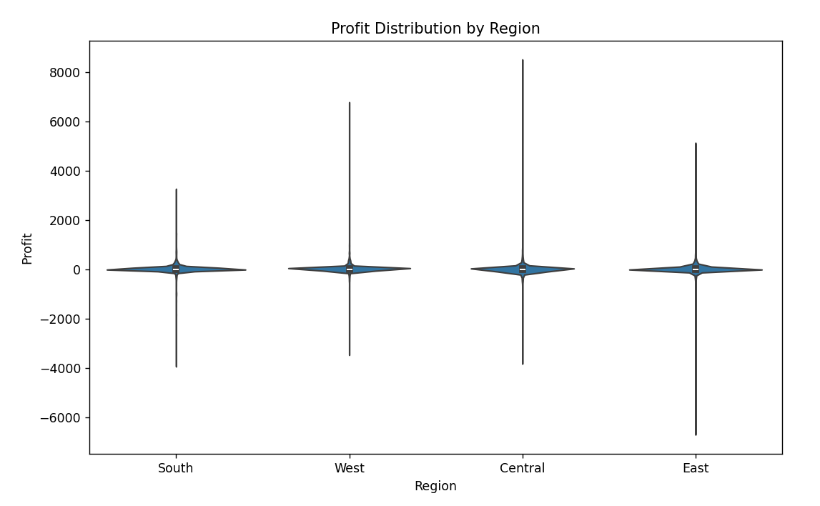*

## Justification of Columns and Insights from Visualizations

**Bar Graph (Sales by Category/Region):** The quantities across categories/regions are compared to demonstrate which area works the best.

**Box-Whisker Plot (Profit by Category):** Distribution and outliers will be useful to assess category profitability.

**Pie Chart (Sales by Region):** Proportions are displayed, highlighting regional contributions to total sales.

**Scatter Plot (Discount vs. Profit):** The relationships between variables are exposed to find an optimal discount level.

**Histogram (Distribution of Sales):** Shows frequency distribution, identifying common sales ranges and outliers.

**Heatmap (Correlation Matrix):** Visualizes correlations between numerical variables, revealing key relationships.

**Violin Plot (Profit by Region):** Combines distribution and density, identifying regions with high profit variability.

# Conclusion

I have proposed the development of an efficient database system for Bhatbhateni Supermarket, one of the leading retail chains in Nepal. The existing system faced a lot of problems brought about by outdated processes and inefficiencies in the management of inventory, sales, and customer data. Solutions to these questions, I will normalize the database to at least 3NF to have less redundancy for better consistency. I then also created an ER diagram to visually demonstrate the relationships from the data; for the modification of data, I used MySQL to complete various operations. Additionally, Python was used to generate graphs of operational data for the supermarket: line charts, bar graphs, histograms, box-and-whisker plots, and pie charts have been helpful in the understanding of different patterns and trends. This project has taken shape from knowledge and skills extracted from the module Database Systems taught by Mr. Ayush Kaji Dangol. In the end, this newly developed database system will highly improve data management to enhance operational efficiency in the supermarket.

# References

Beaulieu, A. (2020). Learning SQL: Generate, manipulate, and retrieve data. O’Reilly Media.

GeeksforGeeks. (n.d.). Introduction to database normalization. GeeksforGeeks. Retrieved January 26, 2025, from [https://www.geeksforgeeks.org/introduction-of-database-normalization/](https://www.geeksforgeeks.org/introduction-of-database-normalization/" \t "_new)

Islam, M., & Jin, S. (2019). An overview of data visualization. 2019 International Conference on Information Science and Communications Technologies (ICISCT). https://doi.org/10.1109/ICISCT47635.2019.9012013

Molinaro, A. (2006). SQL cookbook. O’Reilly Media.

Unwin, A. (2020). Why is data visualization important? What is important in data visualization? Harvard Data Science Review. Retrieved from https://hdsr.mitpress.mit.edu/

Visual Paradigm. (n.d.). What is an entity-relationship diagram (ERD)? Visual Paradigm. Retrieved January 26, 2025, from https://www.visual-paradigm.com/guide/data-modeling/what-is-entity-relationship-diagram/

Wilke, C. O. (2019). Data visualization fundamentals: A primer on making informative & compelling figures. O’Reilly Media.

# Appendix

**Database Normalization Excel Sheet**: [https://docs.google.com/spreadsheets/d/1AZp8-Arq4JUWwO0F3xWwMVIktc14bHjhFZwniHL8vLA/edit?gid=0#gid=0](https://docs.google.com/spreadsheets/d/1AZp8-Arq4JUWwO0F3xWwMVIktc14bHjhFZwniHL8vLA/edit?gid=0" \l "gid=0)

**ER Diagram**: <https://github.com/biplovgautam/database_assignment/blob/main/Untitled%20(2).png>

**SQL Queries**: <https://github.com/biplovgautam/database_assignment/blob/main/Queries.sql>

**Data Visualization script**: <https://github.com/biplovgautam/database_assignment/blob/main/viz.py>